# Farm IT - Workflow Documentation

## 1. Introduction

Farm IT is a digital platform designed to bridge the gap between farmers seeking financial assistance and investors willing to provide funds. The platform securely manages loans, investments, and repayments while allowing administrators to configure financial settings.

# 2. **Workflow Overview**

The workflow of Farm IT is divided into three main user roles: **Farmers**, **Investors**, and **Admins**. Each role has specific functionalities and workflows, which are explained in detail below.

# - 2.1 Home Page

The **Home Page** serves as the landing page for all users. It provides an overview of the platform's features, including:

- A welcoming message.

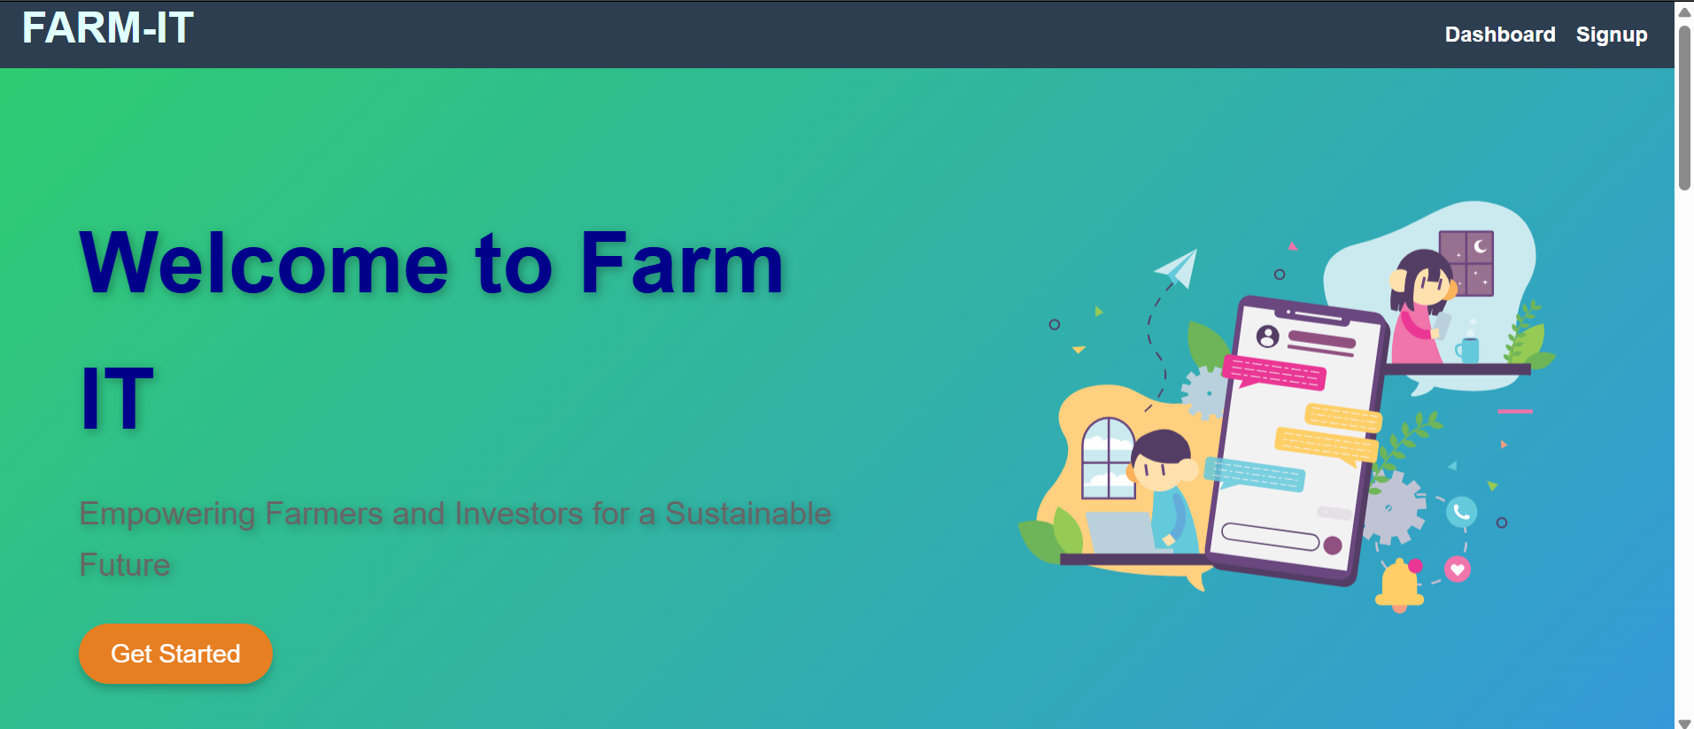

- Key features such as farm management, secure investments, easy loan applications and real-time tracking.

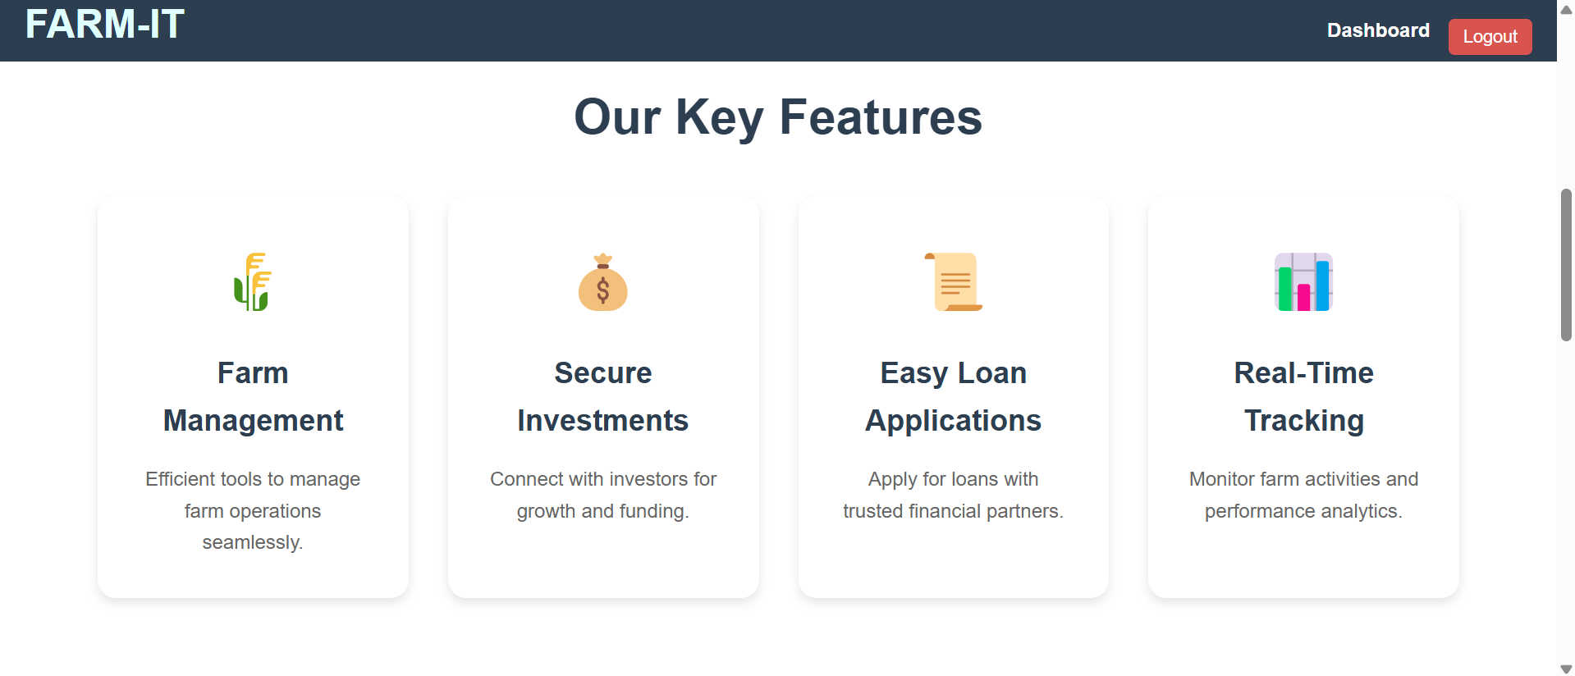

- Call-to-action buttons for **Login** and **Register**.

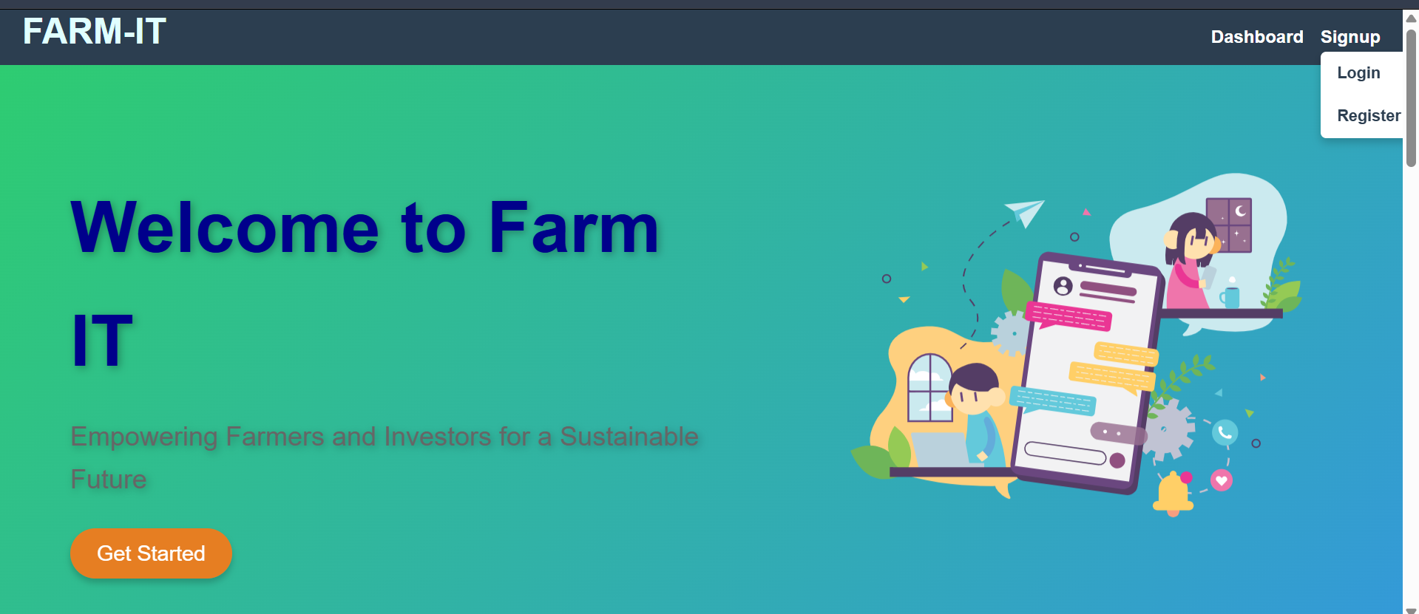

If we hover the signup it will show the Login and Register.

- About Farm-It.

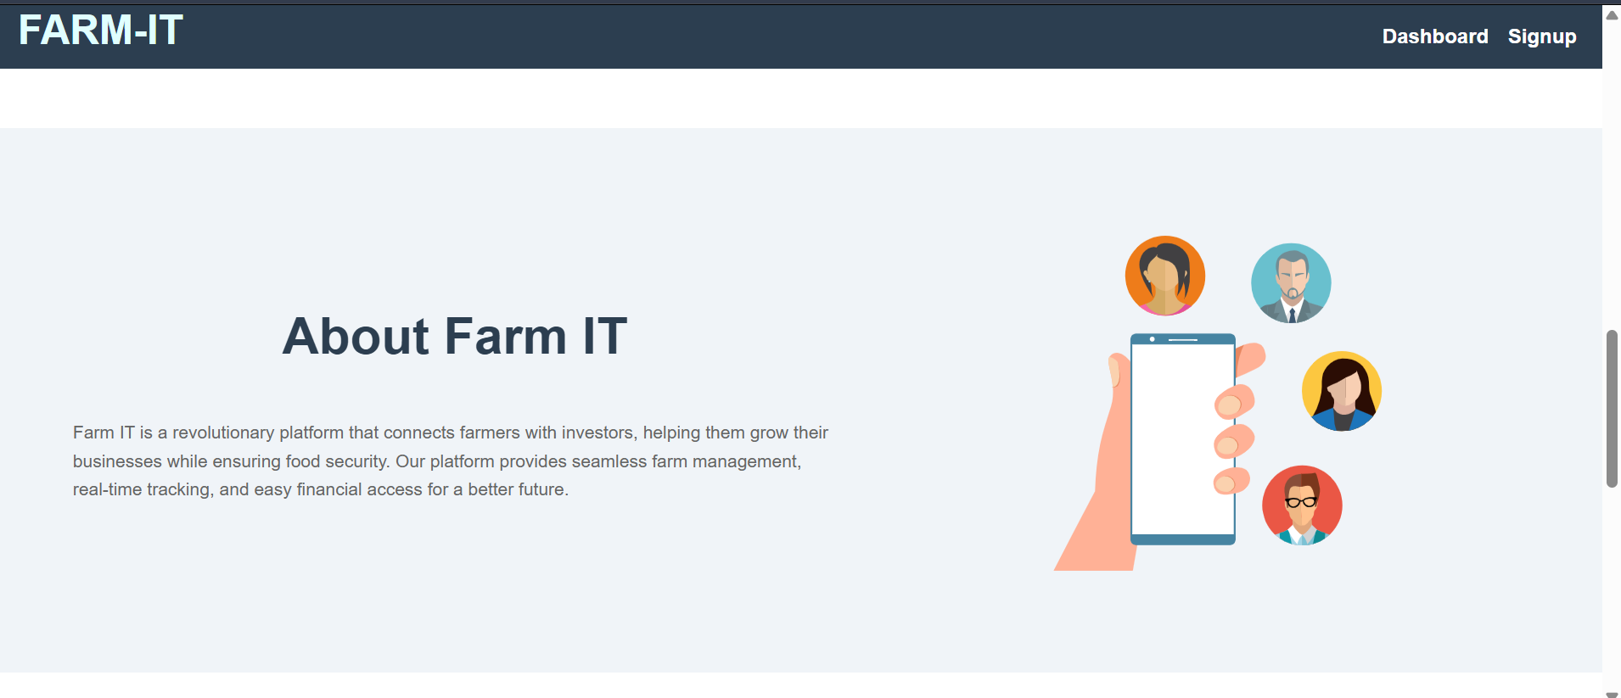

- Join message with action button to register new user.

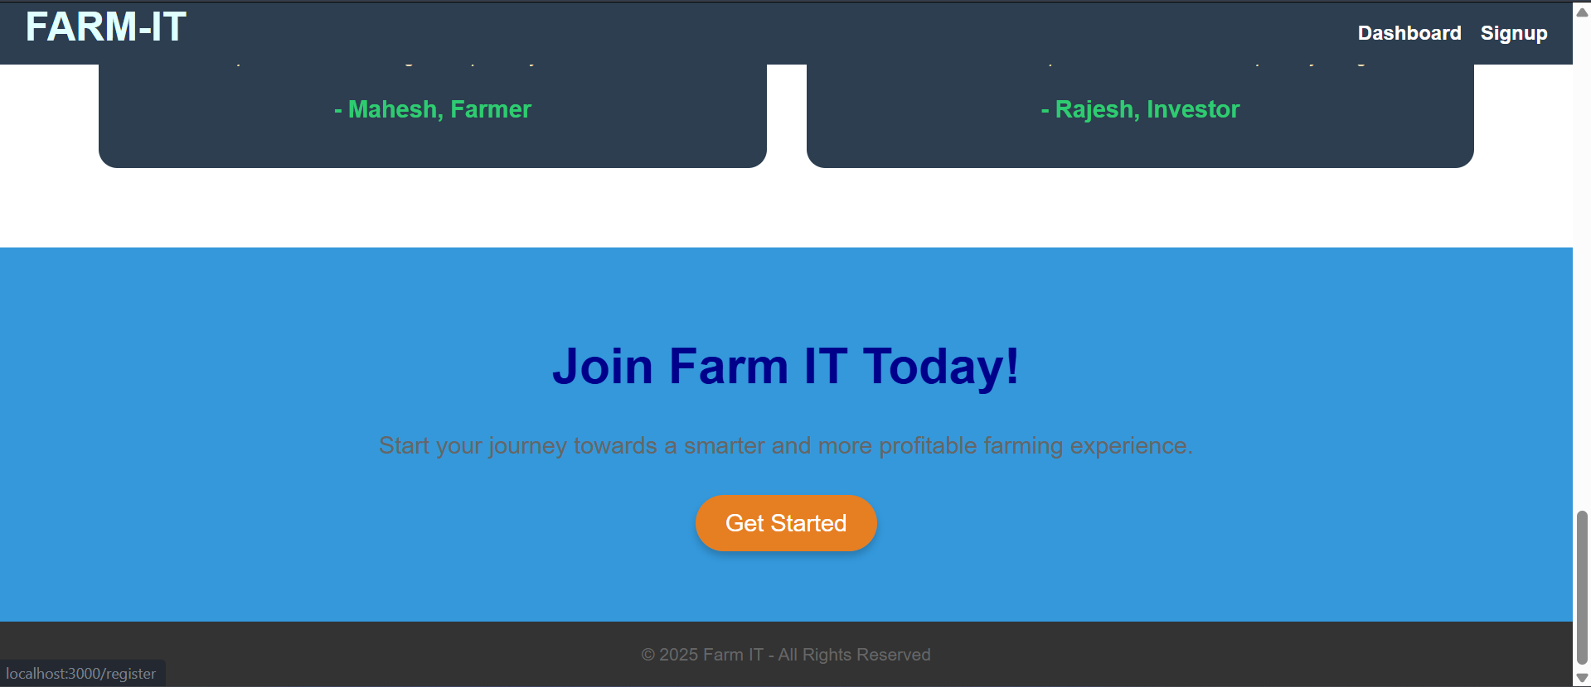

# 2.2 Register page:

Users (farmers and investors) can register on the platform by providing necessary details. The registration process includes:

- Inputting personal information.

* First name
* Last name
* Email
* Password

- Uploading a profile picture.

- Submitting the registration form for **Admin Verification**.

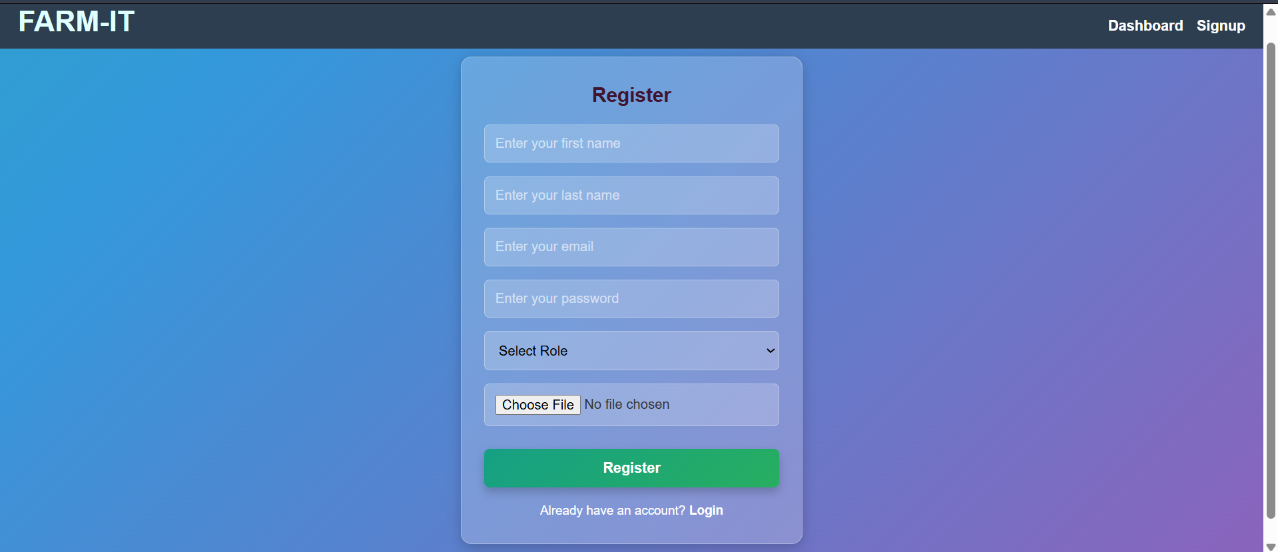

# 2.3 Admin verification:

After registration, the **Admin** must verify the user's account before they can log in. This step ensures that only authorized users can access the platform.

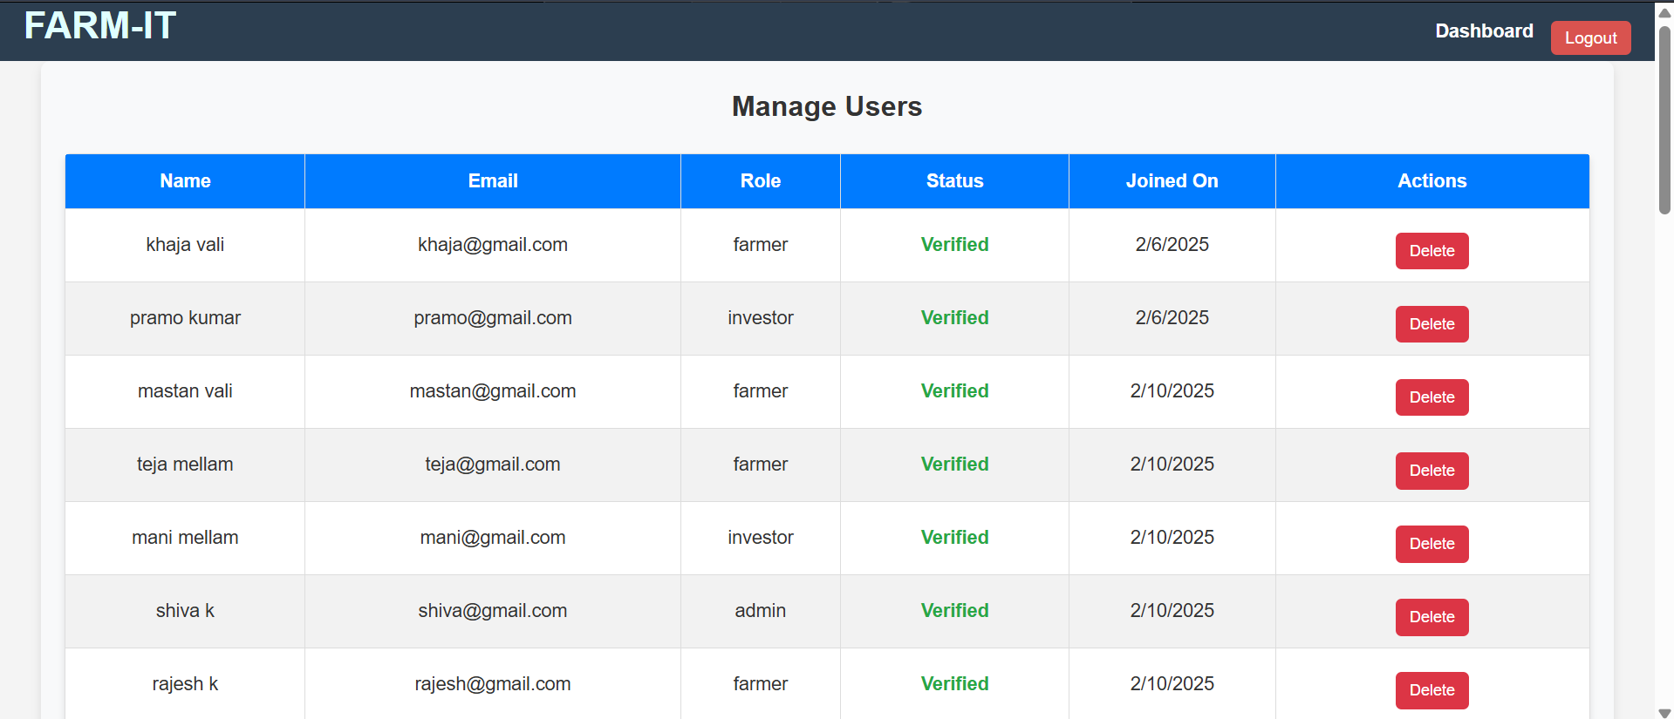

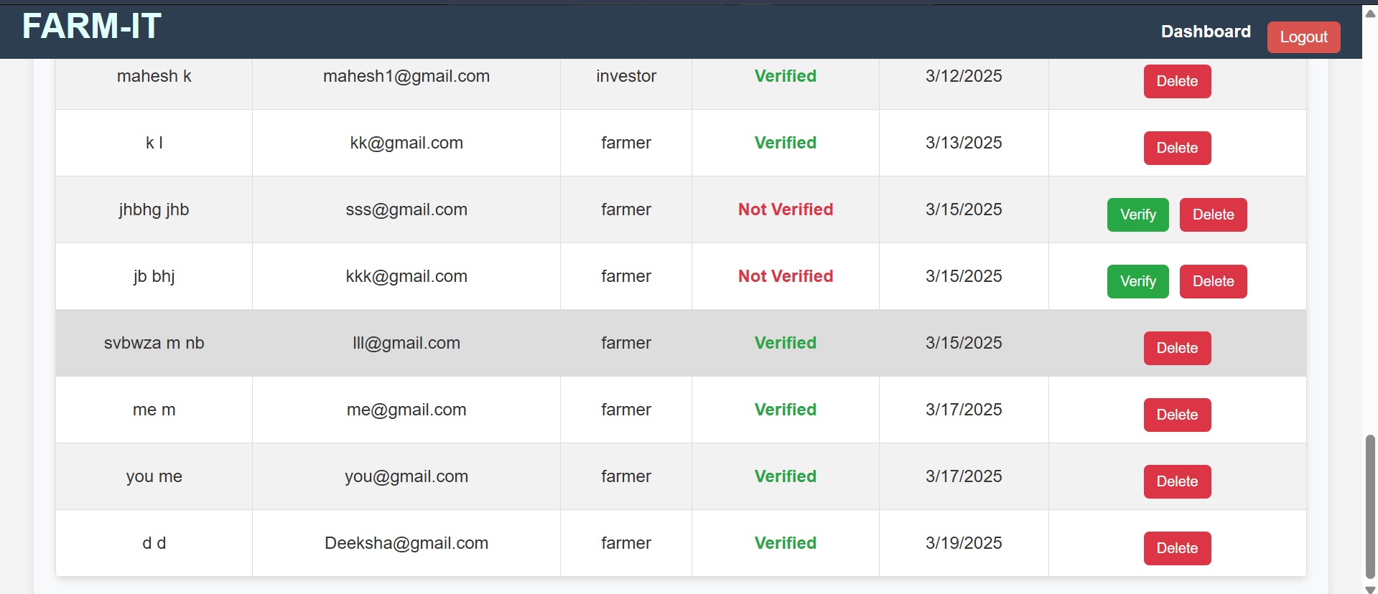

Without admin verification we can’t login into the application.

# 2.4 Login Page:

Once verified, users can log in using their credentials. The system redirects users to their respective dashboards based on their roles (Farmer, Investor, or Admin).

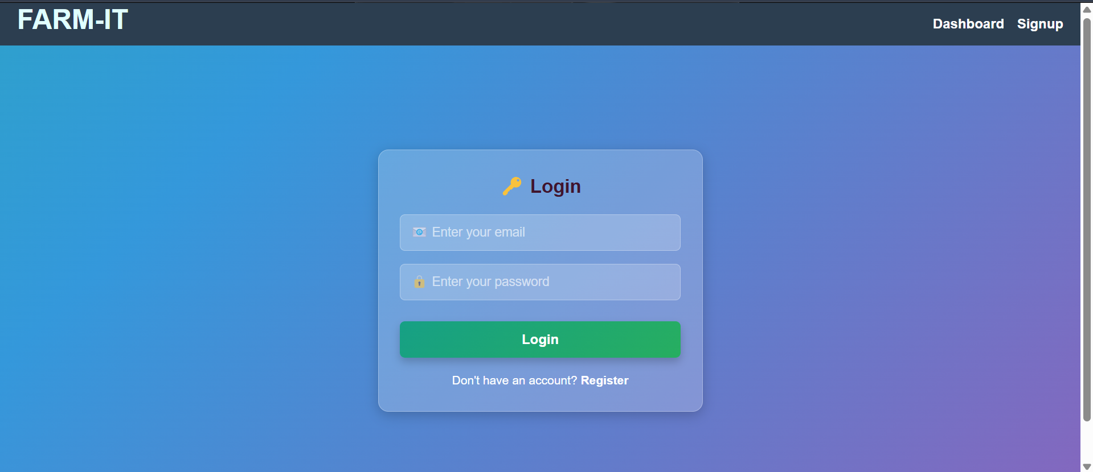

# 2.5 Farmer dashboard:

The **Farmer Dashboard** is the central hub for farmers. It allows them to:

- View their profile.

- Register farms

- Manage farms.

- Request loans.

- Track repayments and transactions.

- Report issues.

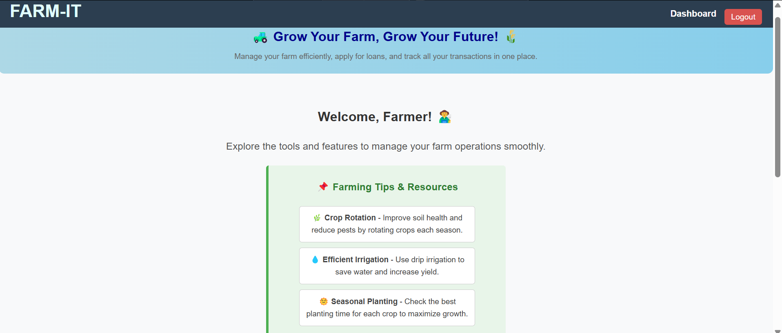

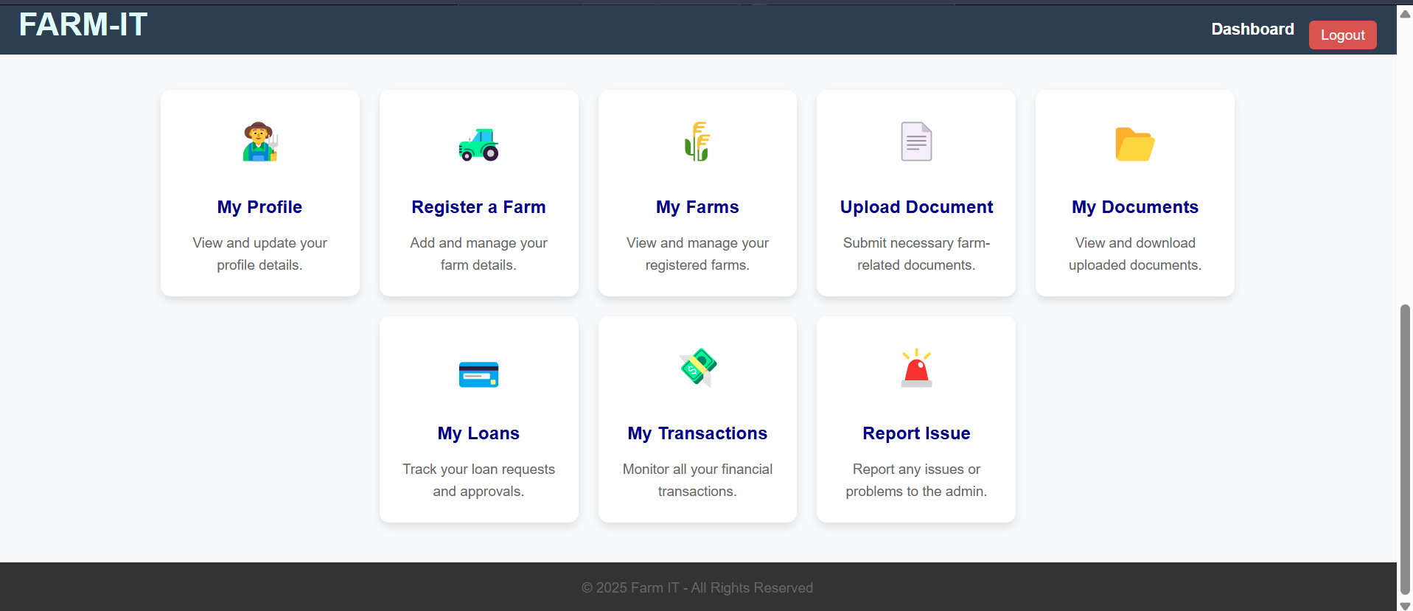

# 2.6 Farmer profile:

Farmers must upload identity and farm ownership documents for verification. Without **Admin Verification**, farmers cannot add farms or request loans.

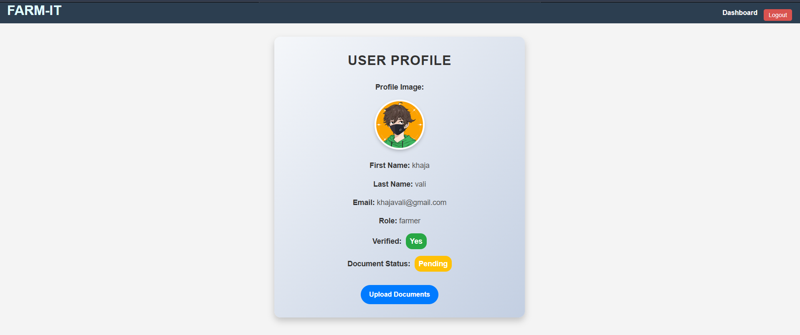

After clicking the upload documents button, it will redirect to the upload document.

Then, it needs verification in admin dashboard.

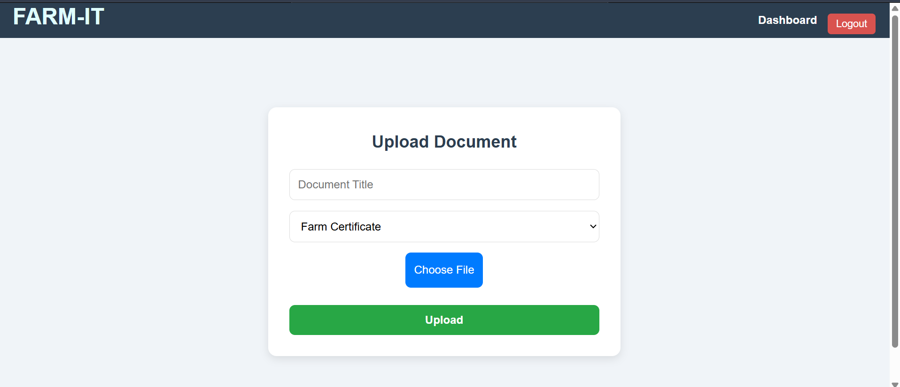

# 2.7 Document Verification by Admin:

The **Admin** reviews and verifies the documents submitted by farmers. If the documents are correct, the Admin approves them, enabling farmers to proceed with farm creation and loan requests.

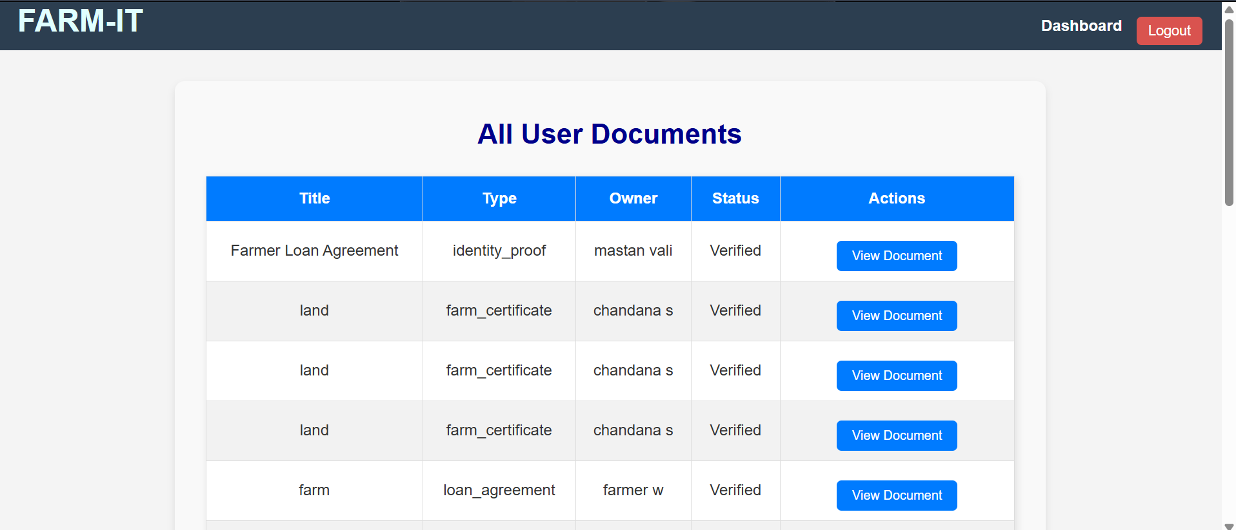

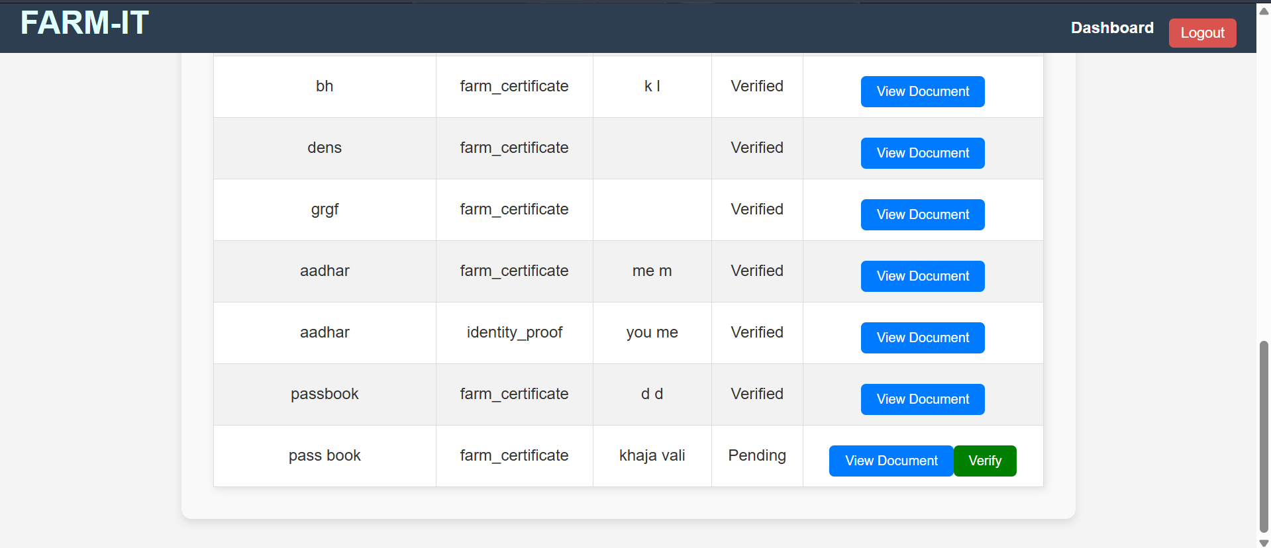

# 2.8 Document Status Update (farmer profile):

Once the Admin verifies the documents, the status is updated in the farmer's profile.

After verification it allows farmer to add farm.

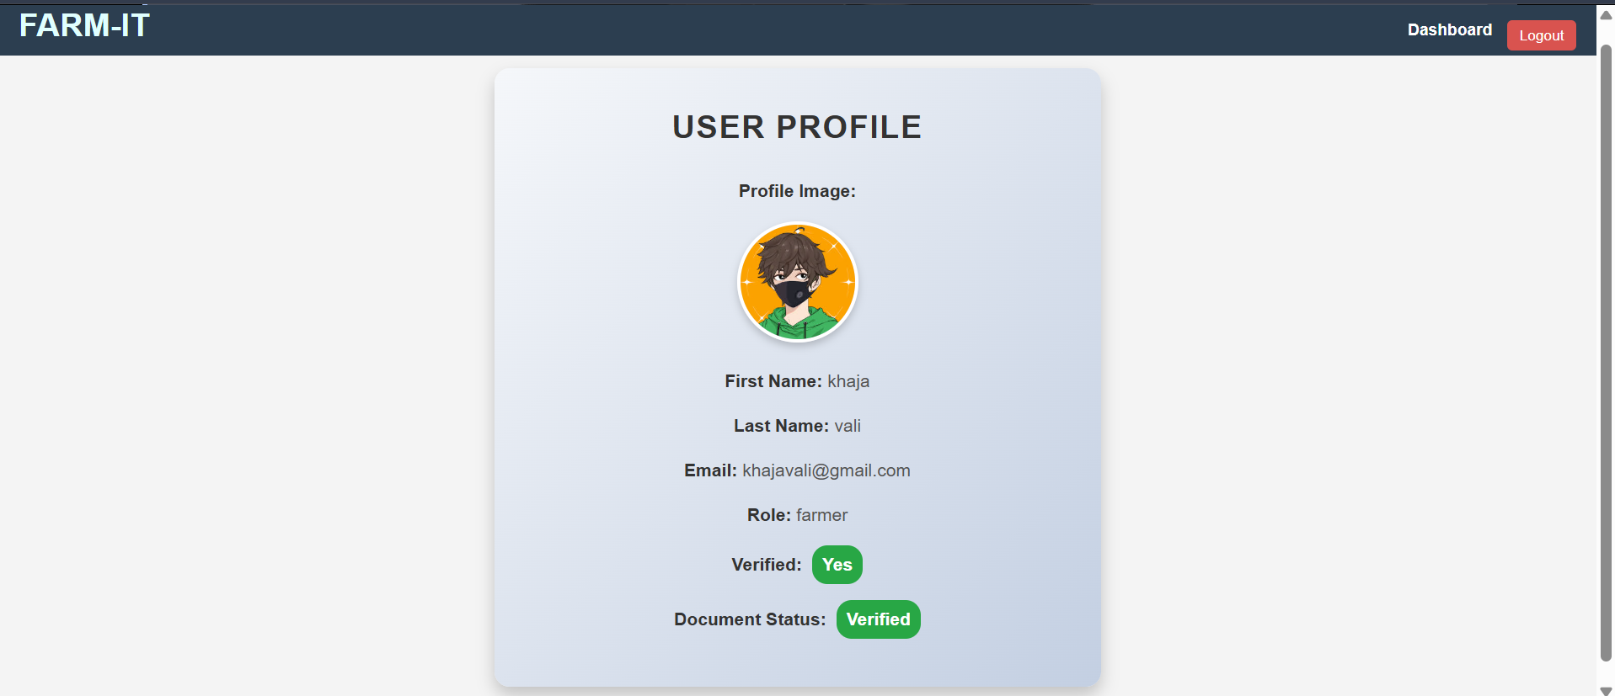

# 2.9 Add Farms:

After document verification, farmers can add their farms to the platform. This includes providing farm details such as farm name, location, farm size, type, description and farm image.

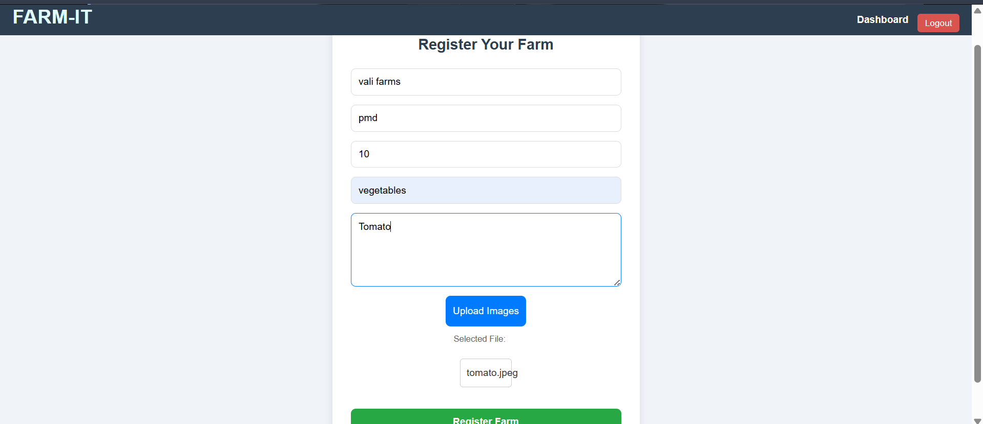

# 2**.10 My Farms (Farmer):**

Farmers can view, edit, delete, and manage their farms. They can also raise loan requests for specific farms.

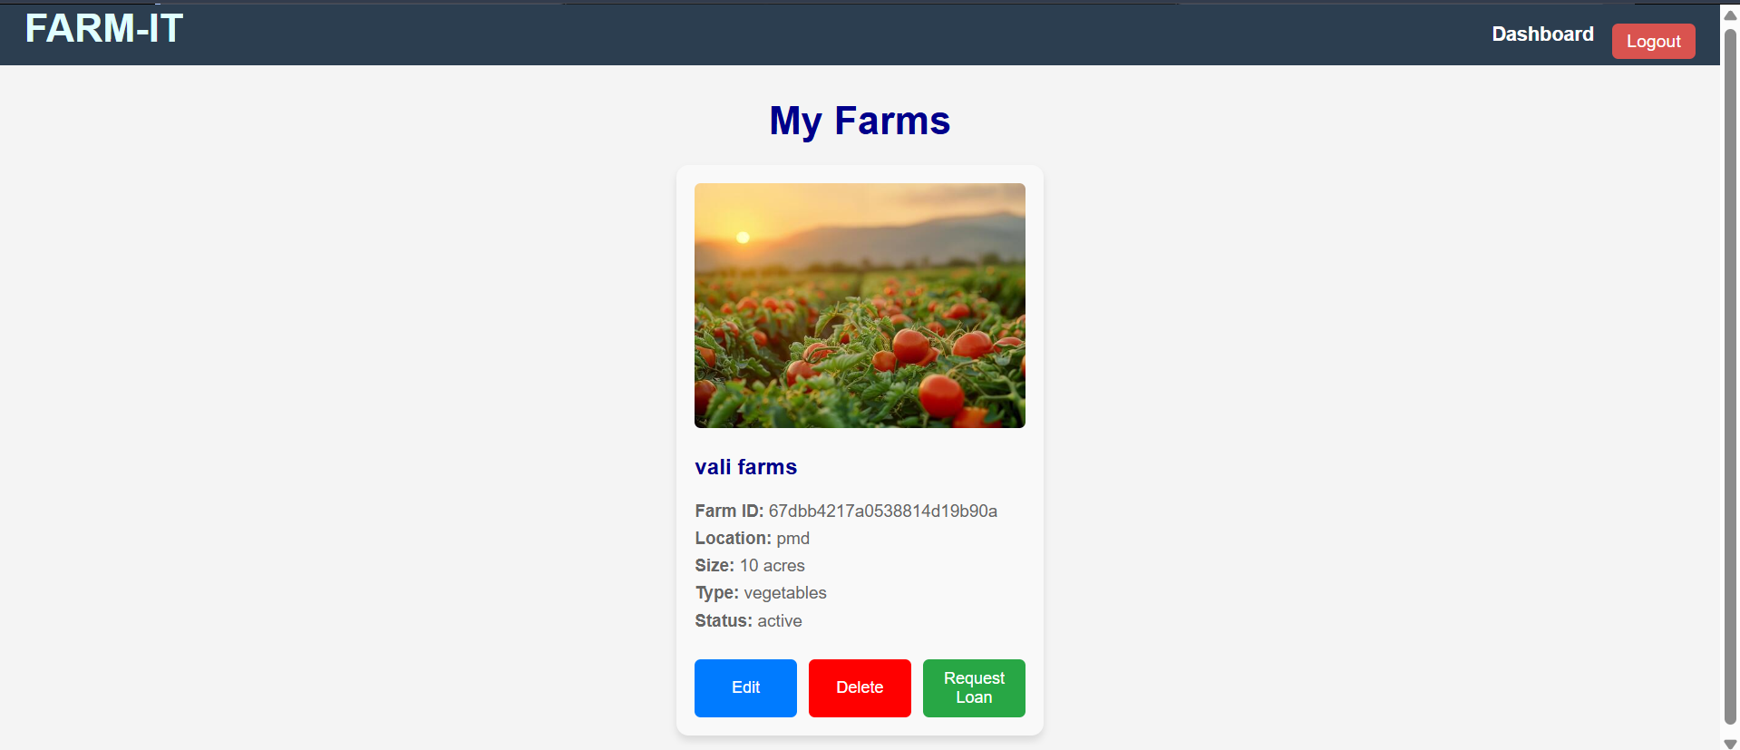

Edit: Farmers can update farm details.

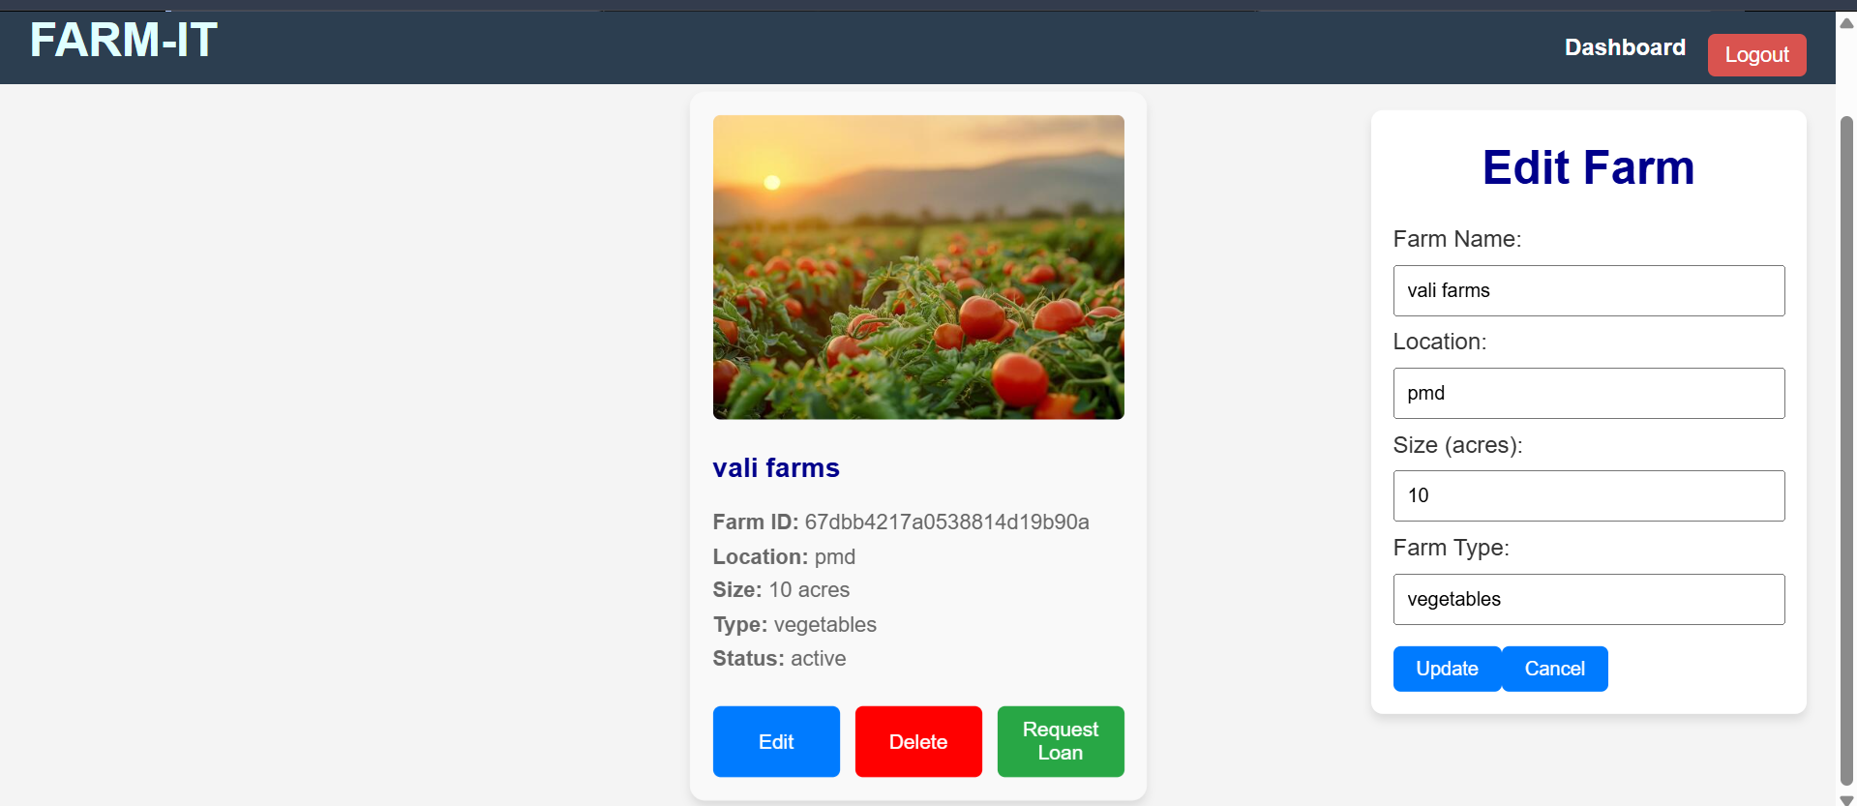

Request loan: Farmers can submit loan requests, which will appear in the **Investor Dashboard**.

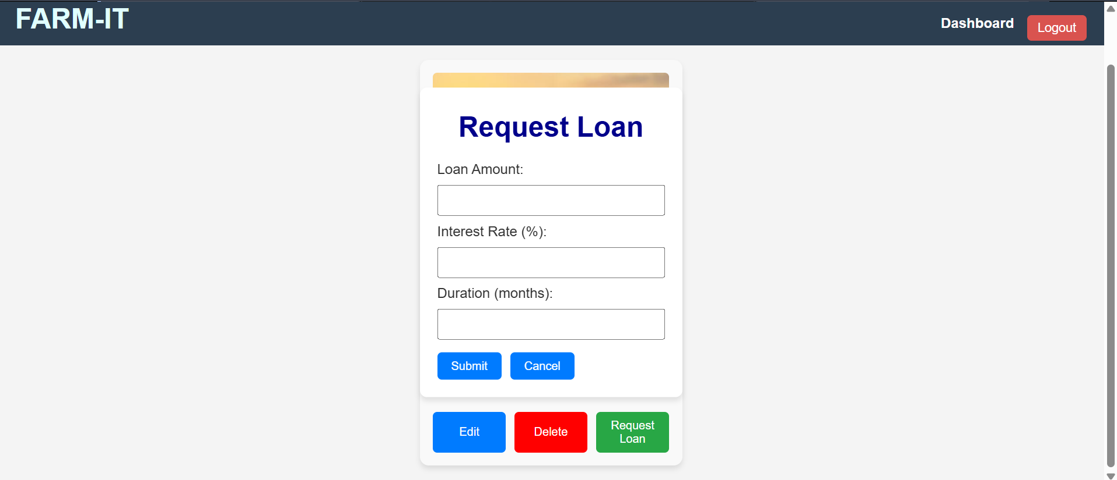

After clicking the request loan button, it will pop up the loan form.

# 2.11 Investor Dashboard:

The **investor Dashboard** is the central hub for investors. It allows them to:

- View all farms.

- Invest in a Farm.

- My investments and transactions.

- Transaction Analytics.

- Report issue.

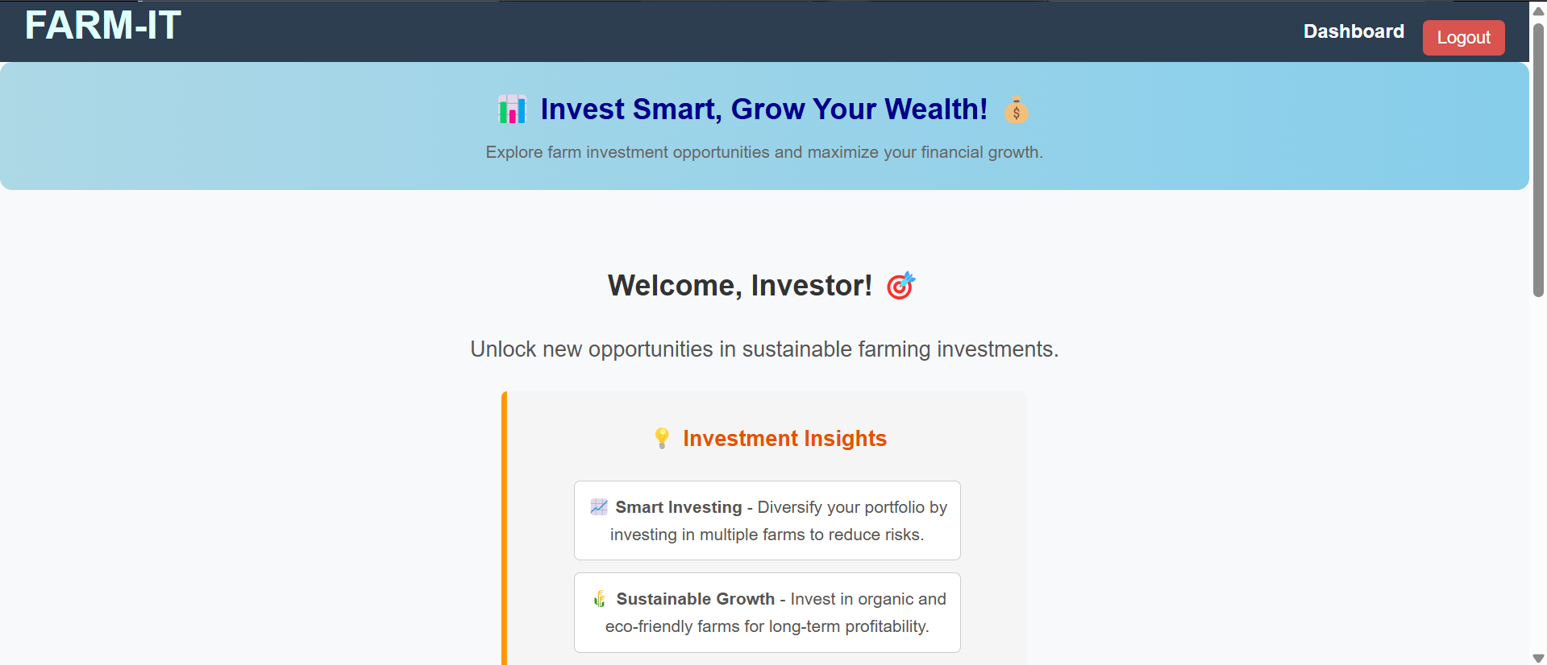

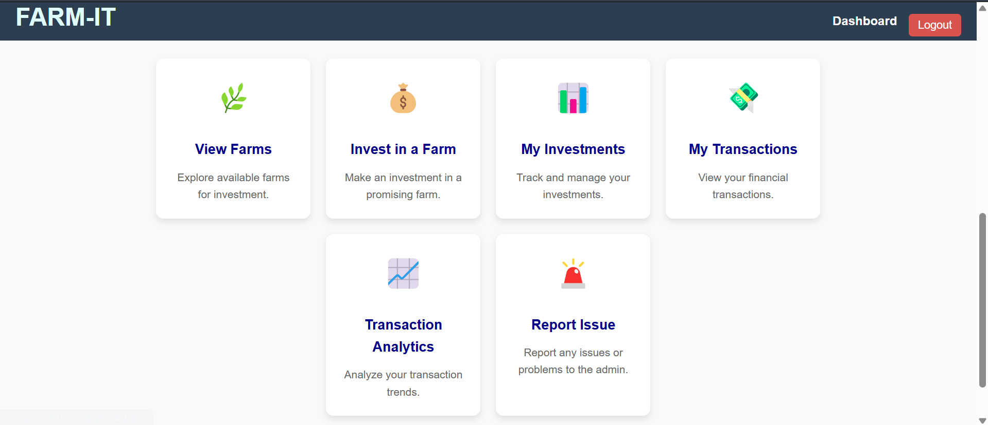

The **Investor Dashboard** displays all available loan requests. Investors can browse farms and invest in loans by filling out an investment form.

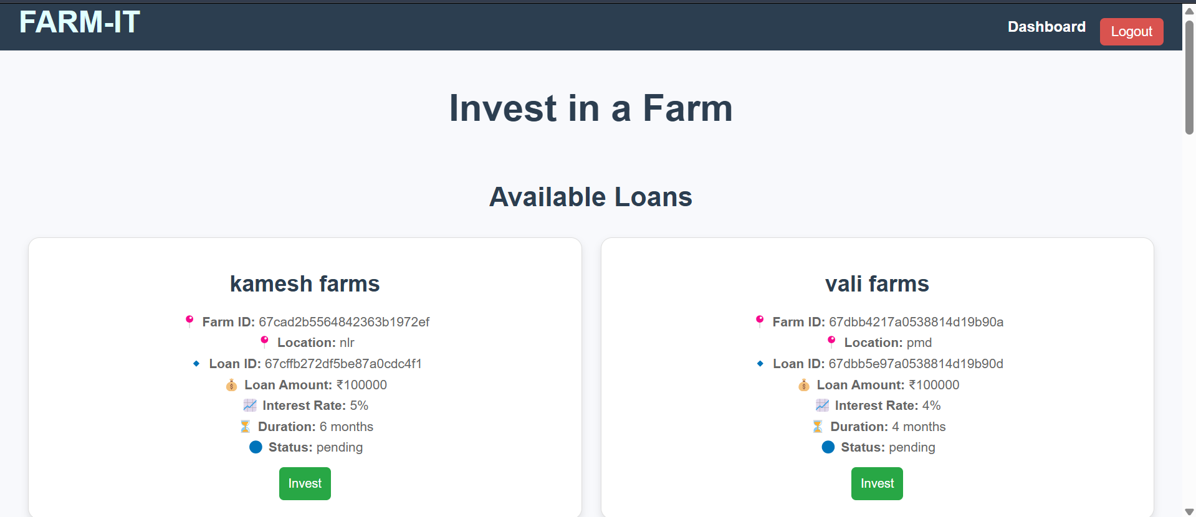

After clicking the invest button it will pop up like this, if investor invest in that farm, it will go to admin dashboard for approve investment.

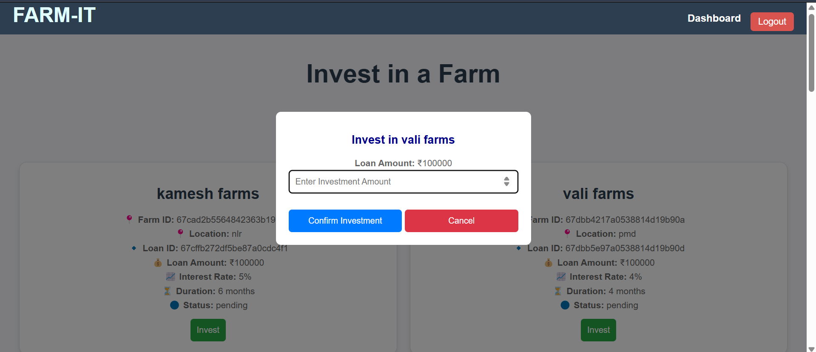

# 2.12 Verify and Approve Investment (Admin):

The **Admin** verifies and approves investments. Once approved, the investment amount is credited to the farmer's account and debited from the investor's account.

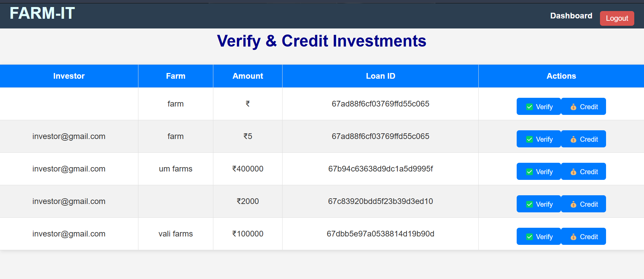

# 2.13 Farmer My Loans:

Farmers can view their loan details, including repayment schedules. They can also repay loans directly from this section.

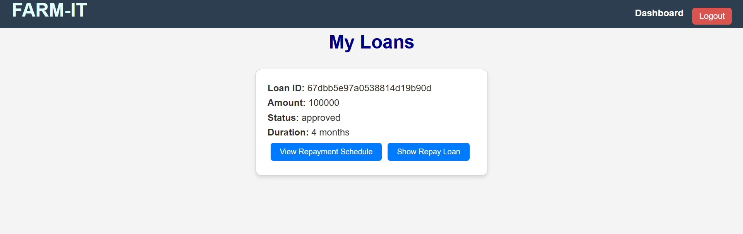

If view the repay schedule and repay loan it shows like this 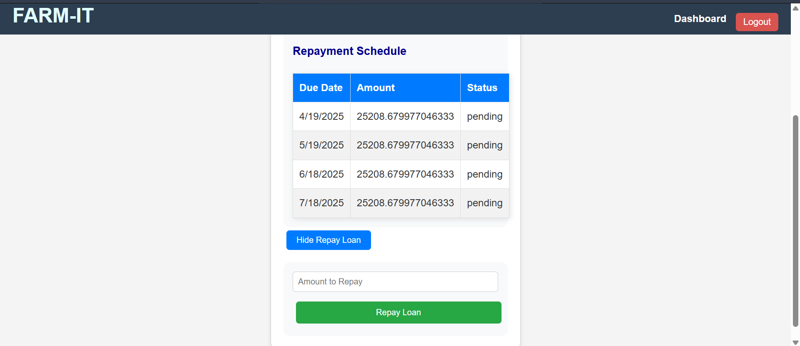

# 2.14 Transactions:

The **Transactions** section displays all financial activities, including investments and repayments. Users can view detailed transaction histories.

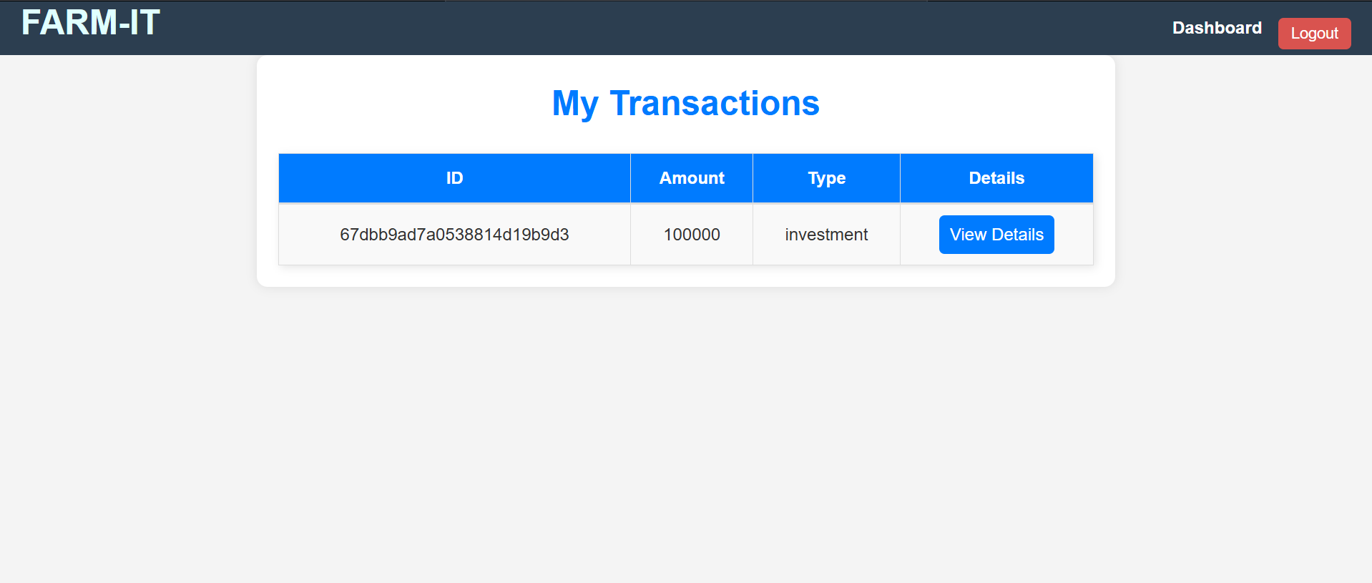

If we click view details it shows like this

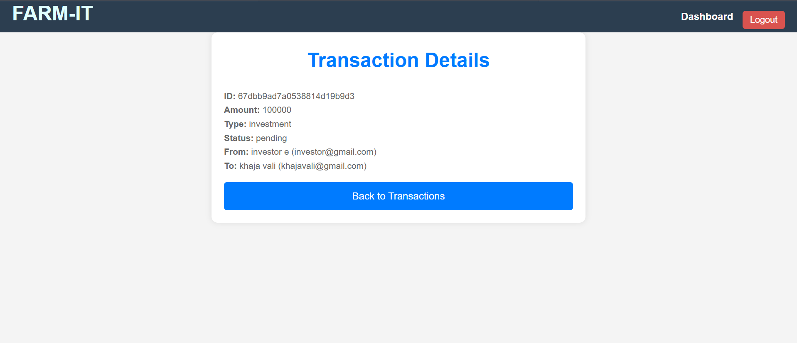

# 2.15 Report Issue:

Users (farmer and investor) can report any issues or challenges they face while using the platform. The **Admin** reviews and resolves these issues.

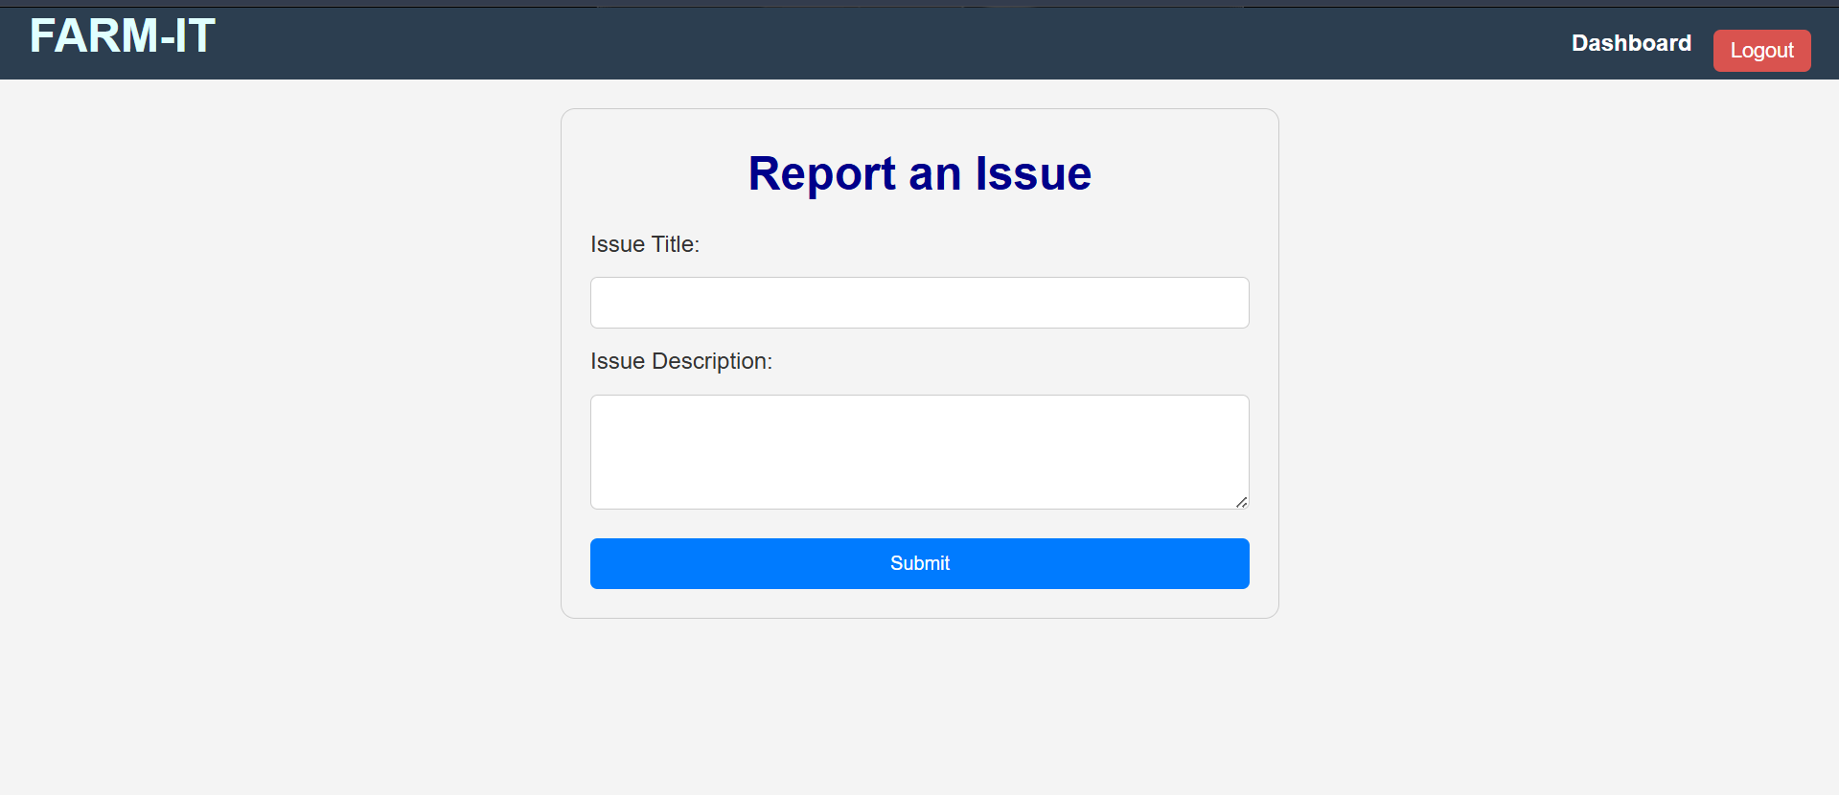

# 2.16 Transaction Analytics (Investor):

Investors can track their investments and view financial analytics, including returns and repayment schedules.

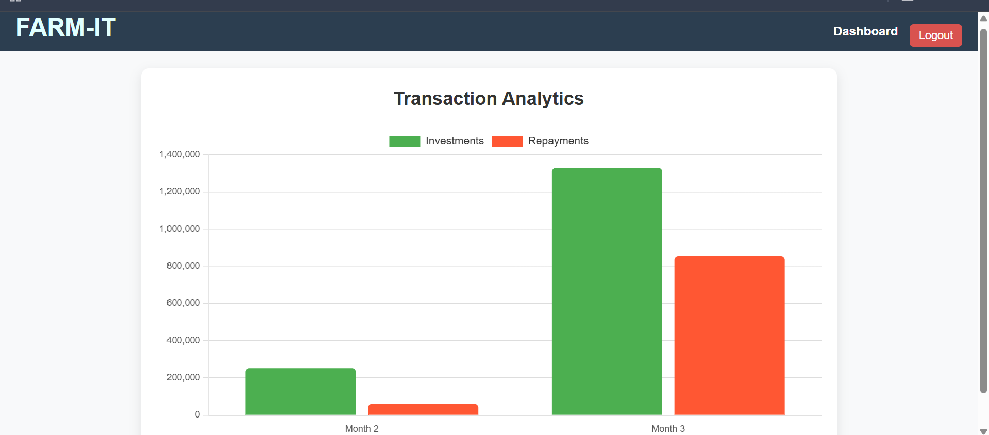

# 2.17 Admin Dashboard:

The **Admin Dashboard** provides a comprehensive view and manage all users, view all users documents and verify, approve pending investments, view of all loans, repayments, and user activities. Admins can also view repayment schedules and loan details.

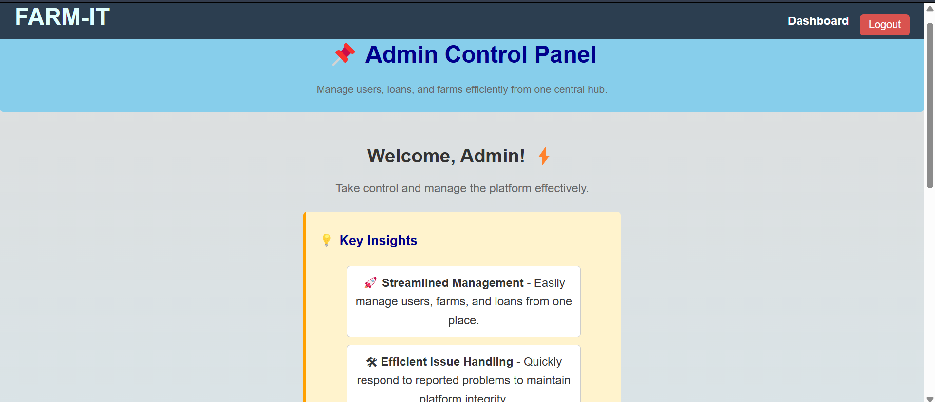

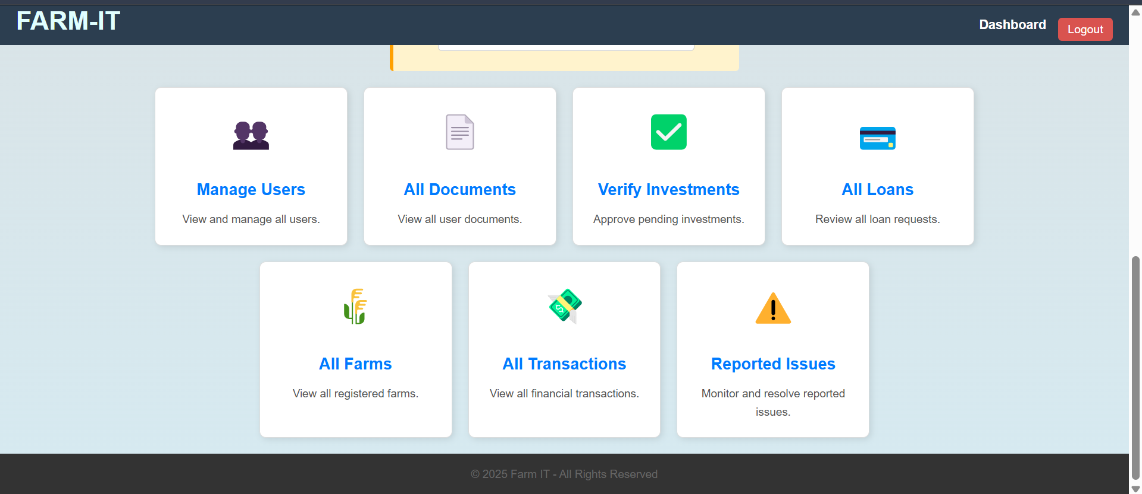

view of all loans:

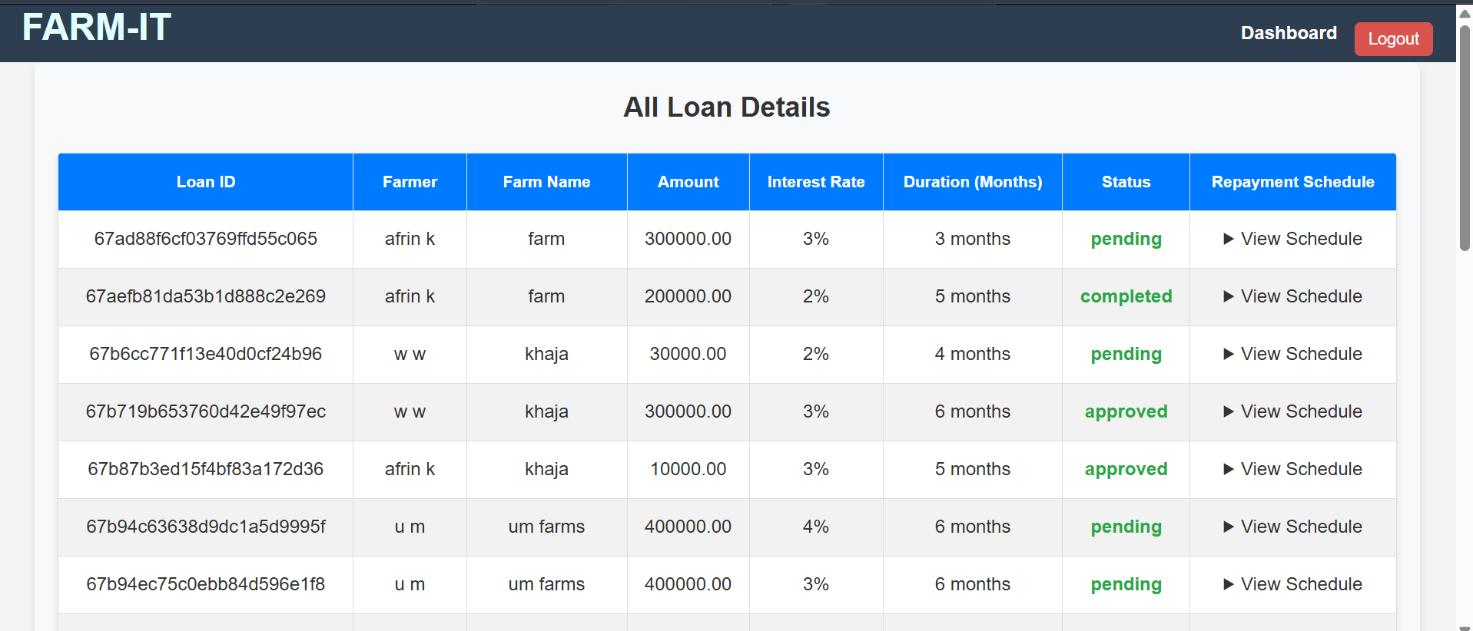

If we click the view schedule it will shows all details.

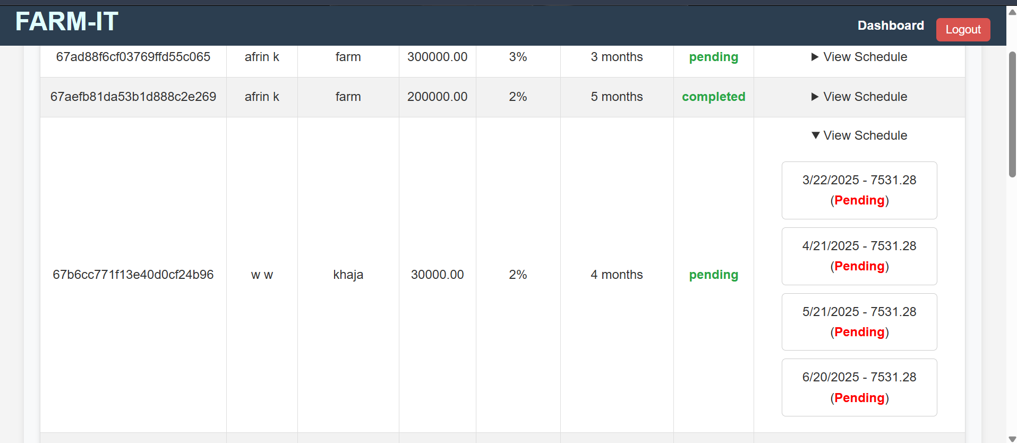

# 2.18 Admin - View Issues:

Admins can view and resolve issues reported by users.

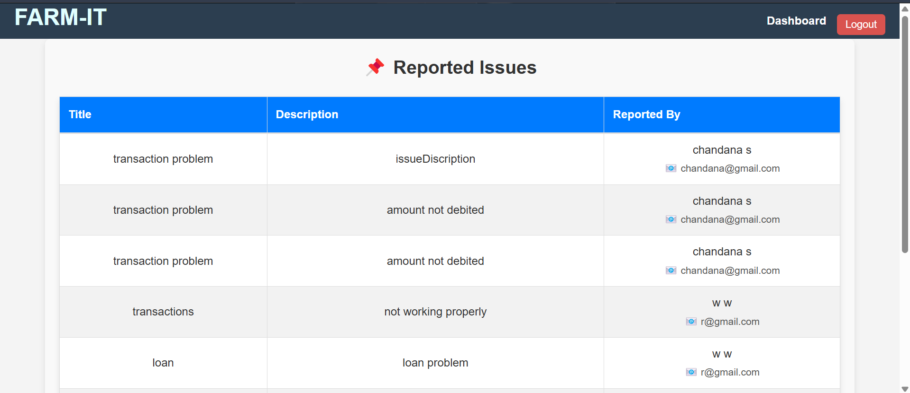

## 3. User Roles & Features

### 3.1 Farmers

Farmers can:

- Register/Login.

- Upload identity and farm ownership documents.

- Create farms and manage farm details.

- Request loans with interest rates and repayment plans.

- Repay loans and track repayment schedules.

- View investment and repayment details.

### 3.2 Investors

Investors can:

- Register/Login.

- Browse available farms and loan requests.

- Invest in farm loans requested by farmers.

- Monitor investments and track earnings.

- View repayment schedules.

- Track financial analytics.

### 3.3 Admin

Admins can:

- Manage user accounts (Farmers & Investors).

- Verify and approve user registrations and document submissions.

- Monitor all farms and loan requests.

- Approve or reject investments and credit investments to farmers.

- Manage all transactions of investor and farmer.

## 4. System Flow

### 4.1 User Authentication

**User Registration** - `POST /register` (Registers a new user and uploads a profile picture)

**Admin Verification** - `PUT /:id/verify` (Admin verifies new users)

**Delete Suspicious Users** - `DELETE /:id` (Admin deletes suspicious accounts)

**User Login** - `POST /login` (Users log in and are redirected based on their role)

### 4.2 Farmer Workflow

**Upload Document** - `POST /upload` (Farmers submit verification documents)

**Admin Document Verification** - `PUT /documents/:id/verify` (Admin verifies documents)

**Create Farm** - `POST /farms/` (Farmers create a farm with images)

**Manage Farms** - `GET /my-farms`, `PUT /farms/:id`, `DELETE /farms/:id` (View, update, or delete farms)

**Request Loan** - `POST /loans/create` (Farmers request loans)

**View My Loans** - `GET /my-loans` (Farmers track their loans)

**Repayment Schedule** - `GET /loans/:id/repayment-schedule` (Farmers view repayment details)

**Repay Loan** - `POST /loans/:id/repay` (Farmers repay loans)

** Transaction Details** - `GET/ transactions/my- transactions`, GET/transaction/:id` (farmer can check transaction details)

**Issue**-` POST/add-issue` - (farmer can report the issue from here)

(**Get documents**- ‘GET/my-documents’(for user purpose only ))

### 4.3 Investor Workflow

**Browse Farms** - `GET /farms/all-farms` (Investors explore available farms)

**View Available Loans** - `GET /loans/available-loans` (Investors check loans open for investment)

**Invest in Loan** - `POST /loans/:id/invest` (Investors invest in a farm loan)

**Track Investments** - `GET /my-investments` (Investors monitor their investments)

**View Repayment Schedule** - `GET / transactions/my- transactions ` ,`GET/transaction/:id` (Investors check repayment and investment details)

**Transaction Analytics**- `GET/ transactions/analytics` (Investors check their Analytics)

### 4.4 Admin Workflow

**Manage Users** - `PUT /:id/verify`, `DELETE /:id`, `GET /` (Admin verifies, deletes, and views users)

**Document Verification** - `GET /all-documents`, `PUT /documents/:id/verify` (Admin reviews documents)

**Farm & Loan Management** - `GET /farms`, `GET /loans`, `GET /all-issues` (Admin monitors farms, loans, and issues)

**Investment Approval** - `GET /pending-investments`, `POST /verify-investment`, `POST /credit-investment` (Admin approves and credits investments)

**Transaction Management** - `GET /admin/all-transactions` (Admin oversees transactions)

## 5. Backend Implementation Details

**Authentication**: Uses JWT-based authentication and middleware for security.

**Transactions**: Securely records all financial transactions.

**Investment Management**: Tracks funds, repayments, and investment progress.

**Error Handling & Logging**: Logs errors for debugging and ensures data validation.

## 6. Conclusion

Farm IT streamlines financial interactions between farmers and investors while ensuring admins have full control over approvals and transactions. The system securely manages user authentication, investments, farm creation, and financial transactions with a well-defined workflow.